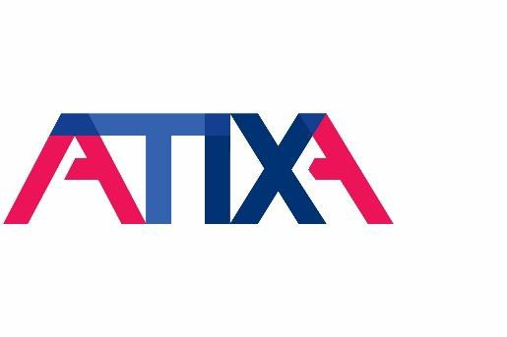
Title IX Coordinator Foundations Level One: Sexual Harassment for Higher Education Training and Certification Course Agenda

Description:
Sexual Harassment for Higher Education is one of two foundational courses in ATIXA’s Title IX Coordinator curriculum for higher education practitioners. This two-day course provides foundational knowledge and skills necessary to oversee and implement policies, procedures, and practices that are compliant with Title IX and VAWA Section 304, as well as other applicable intersecting laws.

ATIXA’s expert faculty members will introduce participants to Title IX compliance oversight responsibilities and guide participants through an in-depth exploration of each stage of ATIXA’s recommended balanced approach to the Formal Grievance Process.

Participants will benefit from engagement with ATIXA faculty members who share examples, explain best practices from their own professional experiences, and answer participants’ questions to cultivate the critical knowledge and confidence Title IX practitioners need to do this challenging and complex work on a day-to-day basis.

In combination with the included Title IX Fundamentals online pre-learning experience, Sexual Harassment for Higher Education meets both the Title IX and VAWA Section 304 training requirements for participants and explores programmatic excellence related to Sexual Harassment prevention and response in higher education.

Learning Outcomes:
After completing this course, participants will be able to…
- Determine which jurisdiction, definition, and process requirements apply based on federal law, state law, and case law
- Understand key requirements from the Title IX Regulations applicable to policies and procedures
- Identify elements of Clery Act/VAWA compliance that intersect with Title IX compliance
- Explain the role of the Title IX Coordinator at each phase of the formal grievance process from intake through appeal
- Identify policy and process overlaps within the institution and recommend solutions for eliminating confusion and/or duplication

475 Allendale Road, Suite 200, King of Prussia, PA 19406 phone (610) 644-7858 | www.atixa.org

- Identify areas of regulatory flexibility to understand both the baseline of compliance and the ceiling of best practices
- Develop recordkeeping protocols that meet regulatory requirements

Course Topics

Title IX Compliance Oversight
- Title IX Statute
- Essential Compliance Elements
- Title IX Coordinator Role
- Title IX Compliance Oversight
- Compliance Considerations

Review: Title IX Scope and Definitions
- Applicability
- Scope
- Definitions
- Activity: Does Title IX Apply?

Formal Grievance Process Overview
- Process Overview
- Prompt Resolution
- Fair Resolution
- Parties’ Rights

Reports, Complaints, and Notice to the Institution
- When is the Institution “On Notice”?
- Point Person for Reports and Complaints
- Mandatory Reporting
- Party and Witness Privacy Concerns
- Report vs. Complaint
- Signing a Formal Complaint
- Interacting with Law Enforcement

Initial Assessment
- Jurisdiction
- Outreach and Intake
- Supportive Measures
- Emergency Removal

- Administrative Leave
- Mandatory & Discretionary Dismissals
- Informal Resolution

Investigation
- Who Should Investigate?
- Investigation Steps
- Determining a Basis for Investigation
- Investigation Scope
- Notice of Investigation and Allegations (NOIA)
- Investigation Strategy
- G.A.S. Framework
- Understanding Evidence
- Directly Related Evidence
- Privileged and Medical Information
- Specific Evidence Issues
- Evidence and the Consent Construct
- Credibility
- Drafting, Reviewing, and Finalizing the Investigation Report
- Parties’ and Advisors’ Review of Investigation Report & Evidence File

Decision-Making
- Decision-Making
- Live Hearings
- Finding and Final Determination
- Standard of Evidence
- Sanctions and Remedies
- Written Determinations

Appeals
- Appeal Process
- Appeal Decision-Maker
- Appeal Grounds
- Appeal Outcomes
- Recordkeeping

Clery Act/VAWA Section 304
- Clery/VAWA Section 304 Intersections
- Prevention

- VAWA Training

Policy Management
- Title IX Policy and Procedures
- Policy and Procedures Development
- Sources of Requirements and Guidance
- Overlapping Policies
- Publication Requirements
- Mandatory Notice of Non-Discrimination

Minors and Title IX
- Minors on Campus
- Common Challenges
- Dual Enrollment and Title IX Compliance
- Camps and Programs: Significant Assistance
- Sample Policy

Trauma-Informed Practices
- Understanding Trauma
- Incorporating Trauma-Informed Practices

Title IX Team
- Meeting Community Needs
- Title IX Team Roles
- Structuring the Title IX Team
- Building the Team
- Training the Team
- Assessing the Title IX Team
- Title IX Team Supervision/Oversight
- Managing Team Member Complaints

Assessing the Title IX Program
- Assessing the Title IX Program
- Title IX-Based Climate Survey Objectives
- Climate Survey Structure
- Climate Survey Report
- Assessment Outcome Sharing

Note: Training will include one morning and one afternoon break (approximately 15 minutes each) and a one-hour lunch break per day. Training start and end times for in-person events are determined by the host site. All virtual training sessions are scheduled for seven hours per day (including breaks) unless otherwise specified. Please check your registration confirmation email and ATIXA Event Lobby for start and end times. All times listed are in the Eastern time zone.

